Report for consumo con posible robo de agua

1. Time Series Characterization
Mean consumption: 88.95226130653266
Median consumption: 14.0
Std deviation: 149.87469235321834
Minimum consumption: 3
Maximum consumption: 792
95th percentile: 512.0499999999994
Total records: 398
Above Normal deviations: 25
Below Normal deviations: 0

2. Consumption Line Plot
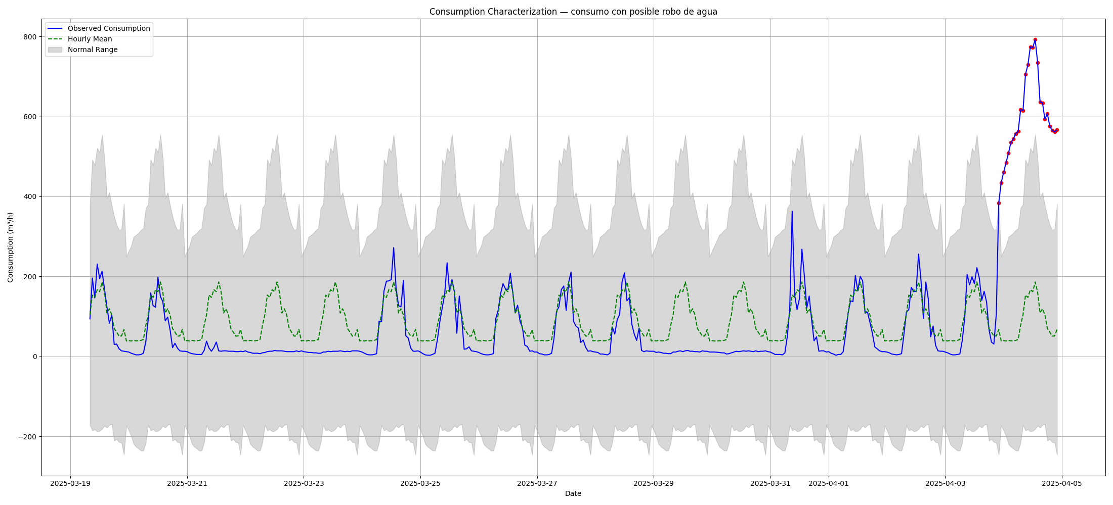

3. Deviation Heatmap
